

# Chudleigh Town Council

# **Environment Committee**

# Tuesday 9th January 2024

## Public Participation:

Dave Smallshire spoke on behalf of Chudleigh Wild regarding the proposed management of the verges along Lawn Drive. Appendix A

## In attendance:

Councillors McCormick, R Webb (chair), Fuller, Bowling, Hadley, Bayley, and Matthews. Also, in attendance was co-opted members Frost, Bushell, Moyse, one member of the public and Amii Shelley (Deputy Clerk)

## Apologies:

Councillor Hares.

## Declaration of members’ interests:

None.

## Confirmation of Part 1 and 2 of the meeting:

The chair advised there would be no part 2

## Urgent matters brought forward by the Chairman:

Councillor McCormick proposed to change the environment committee’s terms of reference to move from quarterly meetings to monthly meetings. Seconded by councillor Bowling, and unanimously agreed. **Action point 1**

## Progress on action points from the meeting on 28th November 2023:

|  |  |  |  |
| --- | --- | --- | --- |
| **Action Point** | **Action Required** | **Responsibility** | **Update 8/1/24** |
| **1** | Seek costings for increased grass cuts on Lawn Drive | Assistant Clerk | Completed. |
| **2** | Organise a contractor and costings for land management at Sensory Garden, Two Oaks, and Bat Garden | Assistant Clerk | Completed. |
| **3** | Arrange for assessment of the cider press | Assistant Clerk | Completed. |
| **4** | Organise graffiti removal at Millstream Meadow | Town Clerk | Completed |
| **5** | Contact local resident about land management of council land. (Millstream Meadow) | Town Clerk | Completed |
| **6** | Organise planting of the large containers in the town | Assistant Clerk | Completed. |
| **7** | Arrange for the playhouse and shop to be checked. | Assistant Clerk | Completed |
| **8** | Organise a meeting with Ines to discuss highways concerns | Town Clerk | Completed |

## Open spaces/wildlife gardener:

Councillor Webb proposed that Chudleigh Wild manage the two verges in appendix A, to include the weeding of pollinator beds, grass cutting and removal of those cuttings, to be reviewed at the end of the 2024 growing season. Seconded by Councillor Bowling and unanimously agreed. **Action point 2.**

Councillor McCormick proposed the concept of a one off clean up, followed by monthly maintenance at the bat garden, sensory garden and the cider press. This was seconded by councillor Webb and unanimously agreed. **Action point 3.**

## Winter planting:

Nothing to report.

## Footpaths:

Nothing to report.

## Cider Press:

Mike Moyse and councillor Fuller have repaired the roof on the cider press today, but it still needs to be structurally strengthened. Councillor Fuller proposed the expenditure of £100 to cover the materials needed to carry out the works. This was seconded by councillor Hadley, with all in favour. **Action point 4**

## Two Oaks:

Nothing to report.

## Millstream Meadow:

Nothing to report.

## Town Centre Enhancement:

Nothing to report

## Culver Green:

Councillors raised concerns over the current bin emptying schedule. They have requested that all bins are emptied, each visit even if they are only partially full. **Action point 5.**

## Fore Street Park:

Nothing to report.

## The Gardens:

Councillors were informed that work to clear the vegetation from behind the railings began today.

## Highways Issues:

Councillor Bayley noted that the bench at Milestone Cross had sustained some damage. **Action point 6**

## Correspondence and Clerk’s report:

Nothing to report

## Allotments:

Councillors unanimously agreed to completely clear the site at plot 53 Exeter Road in preparation for rotavating and reletting. Proposed by councillor Webb, seconded by councillor Hadley. **Action point 7.**

## Cemetery:

Councillors were informed that the Red Cedar suffered some damage in the strong winds, and that it will be assessed in the next couple of weeks.

## Date and time of next meeting: 27th February 2024.

## Meeting closed at 8:20pm

## Action Points

|  |  |  |
| --- | --- | --- |
| **Action Point** | **Action Required** | **Responsibility** |
| 1 | Amend committee’s terms of reference to allow for monthly meetings | Assistant Clerk |
| 2 | Review Lawn Drive verge management Autumn 2024 | All Councillors |
| 3 | Include a proposal to full council for the expenditure of £700 for a one off clean up, and £100 per month thereafter for maintenance at the bat garden, cider press and sensory garden | Town Clerk |
| 4 | Make structural improvements to the cider press | Mike Moyse |
| 5 | Amend the bin emptying procedure | Assistant Clerk |
| 6 | Check the bench at Milestone Cross | Assistant Clerk |
| 7 | Organise site clearance of plot 53 Exeter Road | Town Clerk |

Appendix A

**OPTIONS FOR THE MANAGEMENT OF LAWN DRIVE VERGES BY CHUDLEIGH WILD**

To date, our efforts have been focussed on two sections of verge:

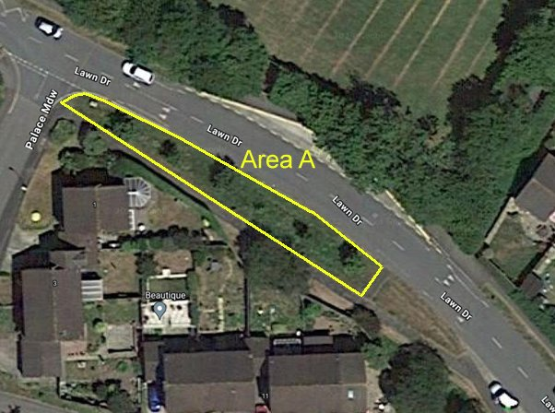

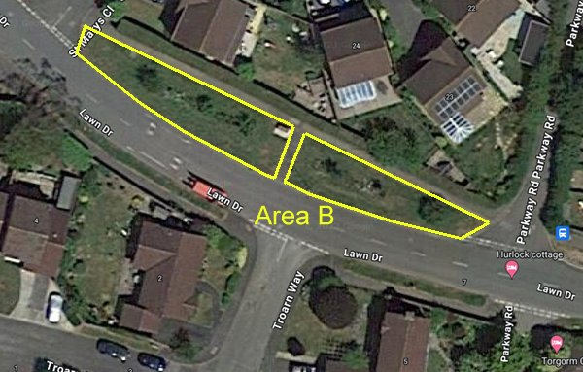

**Area A**

Opposite Chudleigh Primary School playing field and bus stop layby; downhill from the Palace Meadow junction as far as a short footpath crossing the verge, leading to Lawn Drive. At the top end there is a yellow grit container and at the other end the Ox-eye Daisy Nature Trail rubbing post. It is approximately 62 m long by up to 7 m wide, tapering at each end. A strip about 1.5 m wide all around the edge comprises relatively short grass, while the central section is taller and ‘rougher’. Yellow Rattle flowered profusely in parts of the this central section in 2023. The central section also holds six fruit trees and in spring there is a pleasing display of Daffodils.

**Area B**

Lying between St Mary’s Close and Parkway Road. A footpath breaks the area into two sections, roughly 40 and 35 m long, which taper towards St Mary’s Close and Parkway Road, respectively. There is a bench at the bottom end of the top section, where the verge reaches about 9 m in width. The central sections of the verge have a 1 m wide bed with plants known to benefit pollinating insects. The planted species include perennials and biennials; the latter, together with any annuals, need to be (re-)planted or sown into ‘weed’-free soil. The majority of plants die back during the winter, when the beds may appear rather drab, but the dead stems and flower heads provide homes for hibernating insects, including ladybirds and earwigs. A few plants continue to flower in the winter months, providing nectar for specialist insects. The bed is interspersed with six fruit trees. The remainder of the verge has been mown frequently; it is dominated mostly by sown grasses on the footpath side, while the roadside section is much more herb-rich. A Ladybird features on the Nature Trail rubbing post at the top end of the bottom bed, together with a Chudleigh Wild ‘Gardening for Wildlife’ sign.

**Management options**

The suggested options below take note of guidance issued by DEFRA and Plantlife (see Appendix) aimed at benefitting pollinators and wildflowers, respectively, as well as local expertise in managing hay meadows and other wildlife-rich grassland. They also take note of the human resources needed to achieve them.

**Area A**

The roadside verge margin will continue to need frequent cutting for road safety reasons, while similar cutting on the footpath margin will help to maintain the full width of the footpath. These margins needn’t be more than 1 m wide. Ideally, cuttings should be removed to prevent nutrients returning to the soil (grass takes up atmospheric nitrogen, especially from vehicle exhausts along roadsides); alternatively, cuttings should be cut finely and left.

In order to retain the Yellow Rattle (which weakens the grass growth), no cutting should take place until these plants have flowered and set seed. This regime is the same as traditional hay meadow management, which allows a wide range of plants to flower and set seed, thereby benefitting pollinators (bees, flies, beetles, butterflies, moths etc.) as well as other invertebrates (e.g. grasshoppers and spiders) that live amongst taller vegetation. A late-summer cut will also allow Daffodils to flower, although this is primarily for aesthetic rather than ecological reasons (the plants are unlikely to be of native wild origin).

***Recommended management***

* Cut about 1 m of the outer margin at intervals throughout the year, as grass growth demands; remove the cuttings if possible.
* Cut the remainder once between late July and September, early in this period if grass growth is still dominant; leave cuttings to dry for a few days, turning to aid seed drop, and remove. Cut again before the end of the year and/or in February-March, depending on growth.
* Prune the fruit trees, in part to prevent obstruction to traffic, pedestrians and grass cutting.
* Introduce Ox-eye Daisy to the central section, to link to the Nature Trail rubbing post.
* Chudleigh Wild may be prepared to fund the installation of an interpretation board.

**Area B**

This area features planted beds that raise awareness of the plight of pollinators and exhibits some of the plants that passers-by might put into their gardens. There is also the opportunity for passers-by to see the many species of insects that use the flowers. However, these beds require intensive, traditional gardening management and volunteers have struggled to keep them clear of Couch Grass, which reduces the aesthetic appeal of the pollinator-friendly flowering plants. The beds need regular attention, especially through the warmer months.

The outer margins of the verge need frequent cutting, as outlined for Area A, as does a strip around the pollinator beds to allow access. The remainder can be cut less frequently, with options to either cut as frequently as the margins or to allow plants to grow and flower during the summer like a hay meadow, with a late summer cut and ideally the cuttings removed. The latter option is best suited to the verge on the road side of the beds, which is less grassy and more herb-rich.

***Recommended management***

* Maintain the pollinator beds ‘weed’-free and attractive to insects and passers-by, by planting or sowing suitable plants as needed each year; volunteers or paid gardener required.
* Cut about 1 m of the outer margin and a strip around the pollinator beds at intervals throughout the year, as grass growth demands; remove the cuttings if possible.
* Cut the remainder either:
  + frequently, like the outer margin of Area A (the verge on the footpath side of the beds is most suited to this); or
  + between late July and September (the verge on the road side of the beds is most suited to this); remove cuttings; cut again before the end of the year and/or in February-March.
* Prune the fruit trees, in part to prevent obstruction to traffic, pedestrians and grass cutting.

**Management requirements**

Mowing margins: mechanical mower, ideally with cuttings removed, every 2-3 weeks during growing season. Chudleigh Wild volunteer: Peter Warn (has own suitable equipment and transport)

Scything: ‘hay meadow’ in Area A cut in August, with cuttings removed; 2 scythers for one day. Chudleigh Wild volunteers: Sue Smallshire and Robin Aaronson, plus rakers (own equipment).

Raking hay cuttings: about six volunteers on 2 days p.a. Chudleigh Wild volunteers: Mandy Cole, Mary Rush, and others.

Disposal of mowings: Peter Warn (for mulching or composting); hay for cattle at Deer Park Farm?

Tending pollinator beds: volunteer Harry Flower, or CTC contractor.

Fruit tree pruning: CW volunteers (Tess Frost and others.)